**Wireless**

1. Wft300n router
2. In config-> wirless
   1. Auth: wpa2-psk
   2. Enc: AES
3. To connect:
   1. Desktop -> connect (wait)

**Commands dhcp via router, assign the ip to wire same as default router <ip>**

1. configure terminal
2. ip dhcp pool mypool
3. network 192.168.1.0 255.255.255.0
   * 192.168.1.0 will change according to network number
4. default-router 192.168.1.1
   * 192.168.1.1 will be same as assigned to wire network
5. ip dhcp excluded-address 192.168.1.2 192.168.1.29
6. exit

* ***extra command*** to allow dns server: dns-server 192.168.1.3
* Default gateway of any server or pc should be of router ip in that network

First you should establish dhcp then connect dns server using ***extra command***

Static routing using GUI:

* Do this for all networks through all hopes for all routers
* When configuring PTRouter0, mask will depend on the class you are using other 2 as following
* When doing by command line use this:

ip route <network> <mask> <nexthope> <z-index>

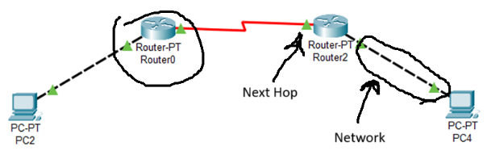

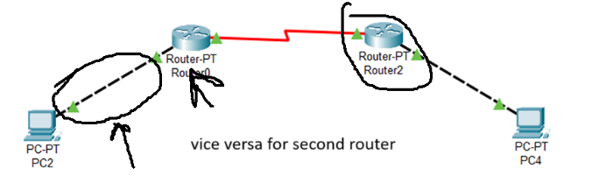

**Task 1: subnet mask will be: 255.0.0.0 since we are using A-Class IP**

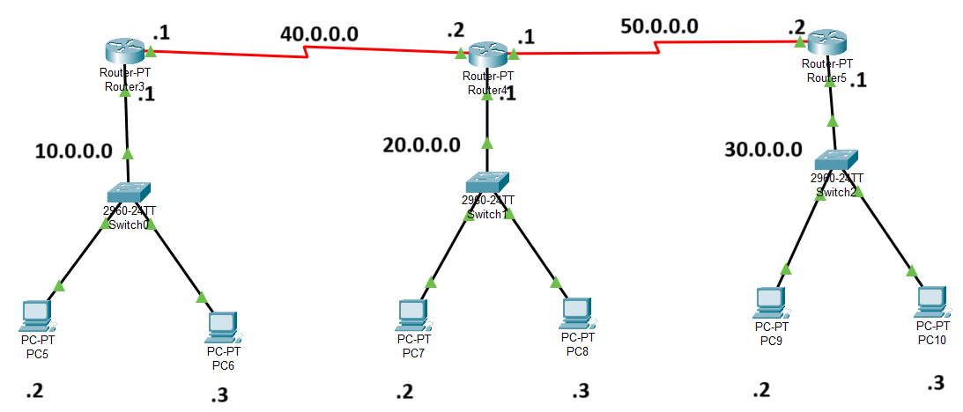

You have to configure each router based on don’t knows to each router, like for router 1

Knows: 10.0.0.0, 40.0.0.0 and Don’t Know: 50.0.0.0, 20.0.0.0, 40.0.0.0 and its immediate hop: 40.0.0.2

Do like this for other routers too

* You can use any class networks can be 192.168.1.0, 192.168.2.0, 192.168.3.0 and so on. But remember that Mask will then become 255.255.255.0

**Task 2:**

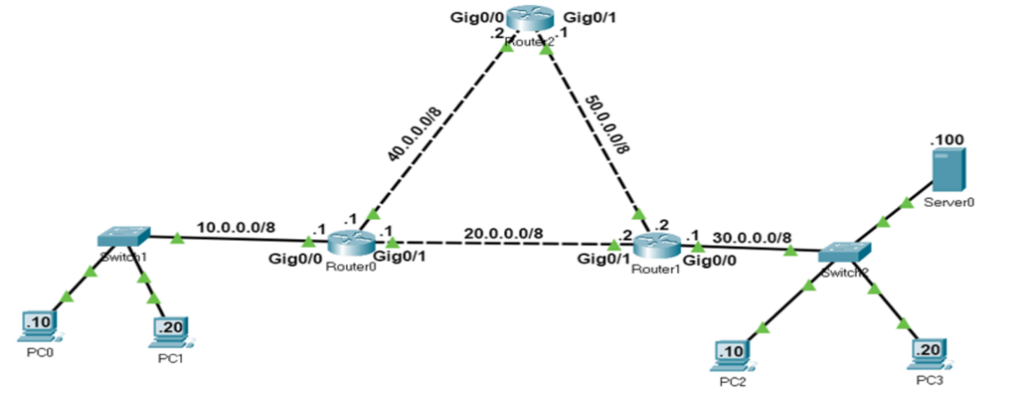

Do same as above but make sure that you access all networks from each next hop of router. Eg router 1:

* Via 40.0.0.2: access network 50.0.0.0 and 30.0.0.0
* Via 20.0.0.2: access network 50.0.0.0 and 30.0.0.0

Do this for all routers too

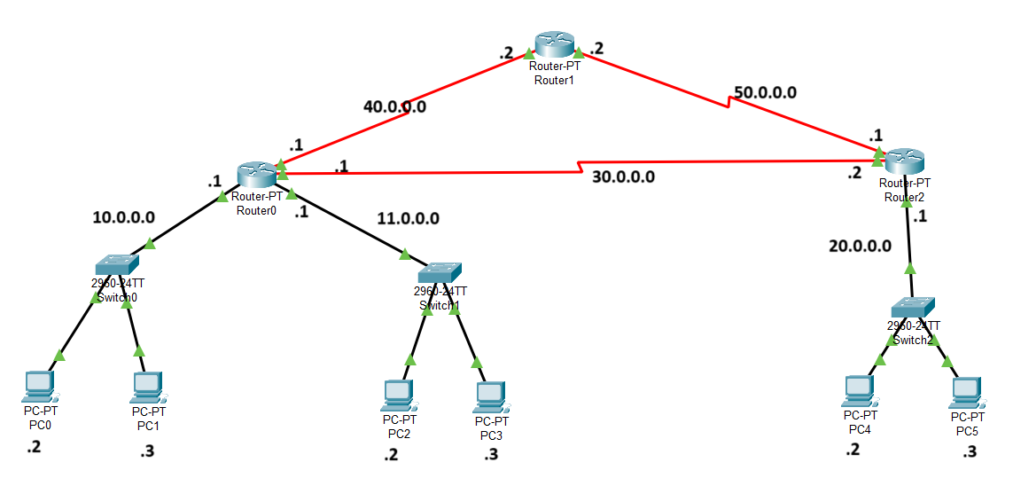**ACL**

It blocks any data from that network and to that network

Apply these 4 commands on cli

access-list 1 deny 20.0.0.0 0.255.255.255

access-list 1 permit any

interface fa0/0

ip access-group 1 out

* Make sure to put in reverse subnet on host part. It worked for 0.0.0.255 but try using one above
* Sometimes that group doesn’t work so do this: *no ip access-group 1 out*, then make new access-group 2.

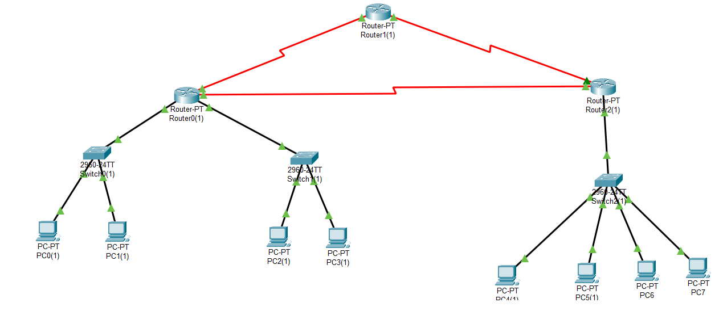**VLAN**

Make vlan within lan, Commands in switch:

enable

configure terminal

vlan 2

name meow

interface range fa0/3-4

switchport mode access

switchport access vlan 2

Name can be any,

vlan should not be 1 since 1 is default for current lan,

range should be of individual pcs you can even make make pc vlan

there should be space between {vlan 2}

**NAT**

Make sure to be in configuration! Not in config-if

Router 1:

**Router 1:**

ip nat inside source static 10.0.0.2 50.0.0.2

ip nat inside source static 10.0.0.2 50.0.0.2

int fa0/0

ip nat inside

exit

int se2/0

ip nat inside

exit

**Router 2:**

ip nat inside source static 20.0.0.2 60.0.0.2

ip nat inside source static 20.0.0.2 60.0.0.2

int fa0/0

ip nat inside

exit

int se2/0

ip nat inside

exit

**After doing this do static routing for these addresses 60.0.0.0 and 50.0.0.0 on both routers**

**Generaly:**

ip nat inside source static <end-device-address> <any-ipv4-address>

ip nat inside source static <end-device-address> <any-ipv4-address>

ip nat inside source static <end-device-address> <any-ipv4-address>

ip nat inside source static <end-device-address> <any-ipv4-address>

… // do for all or 1 device

int fa0/0 // the port you are connecated with on router

ip nat inside

exit

int se2/0 //next port of same router

ip nat inside

exit

You should get output like this on NAT pc in network:

ipconfig

ping 20.0.0.2

ping 60.0.0.2

**DNS using DHCP**

* First give addresses to all pools using dhcp:
* Then give address to DNS server
* Now then go to all pools and give this dns server, for all servers. Don’t do this initially:

ip dhcp pool netA

DNS-SERVER 10.0.0.3

* Then go static to dhcp to apply dns addresses to pcs

Lab can also have this:

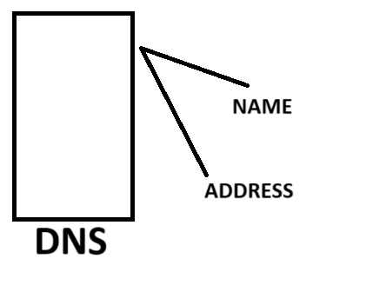Address can be of any other dns server